Muhammad Daniyal Qureshi

BSCS_VII-A

021-18-0009

Hotel BOoking APp in FLUTTER

MAD Semester Project

Contents

**Strategy:** 1

**Analysis and Planning:** 1

**UI /UX Design:** 2

**App Development** 2

**Frontend** 2

**Backend** 2

Sign In 3

Sign up 4

Home 5

Booking 6

Drawer 7

Hotel Info 8

Reservation 9

Date Picker 10

**Testing** 11

**App recording and Source Code Link:** 17

# **Strategy:**

**Users**: Mostly travelers who visits Karachi with their family or alone

**Goals:** It is a usable and excellent UX application that will assist travelers to choose a suitable restaurant for them.

**Platform:**  I selected Flutter for developing this application, because it is cross platform application.

# **Analysis and Planning:**

**Requirements:**  Application will show list of hotels along with their location and features ,users can select any hotel and select any type of rooms available in the hotel.

**Skills:** Usable and customer oriented app, using the material widgets to make responsive application that is compatible with any android device.

# **UI /UX Design:**

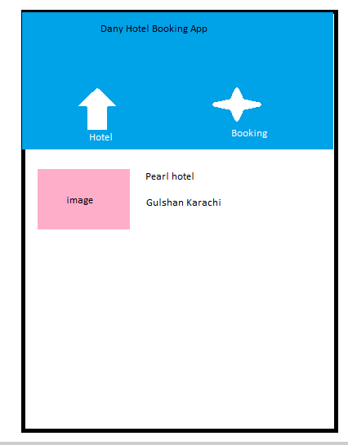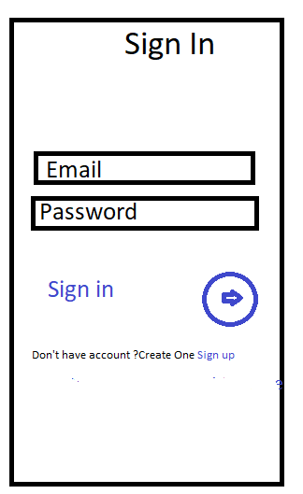

# **App Development**

**Frontend :** Flutter Material Widgets (DatePicker,Stack,ListView, Card Widgets,Tabbed Controller ,Carousel Widget,Drawer, Elevated Buttons, DropDownButton, AwesomeAlertDialog).

**Backend** **:**Sqflite ,SharedPrefereces

## Sign In

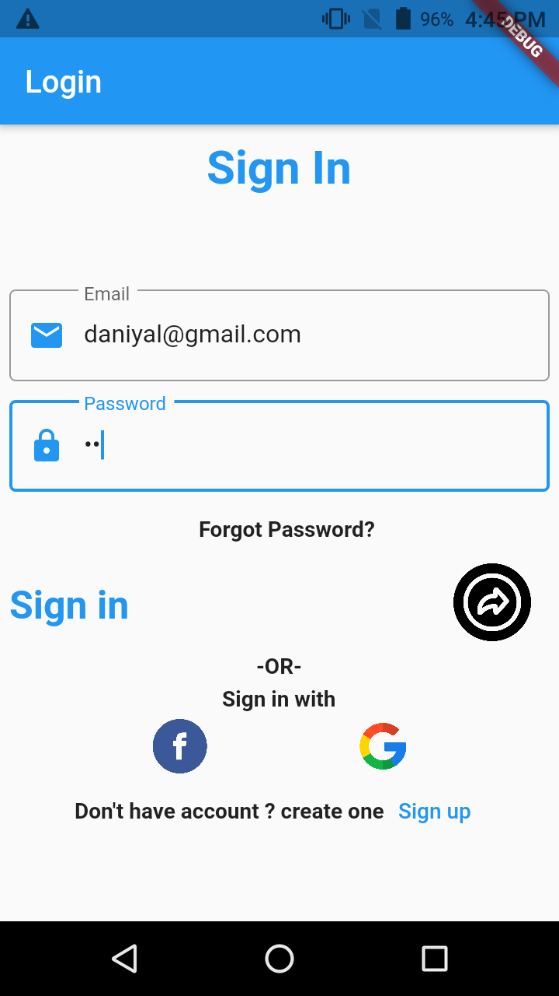

## Sign up

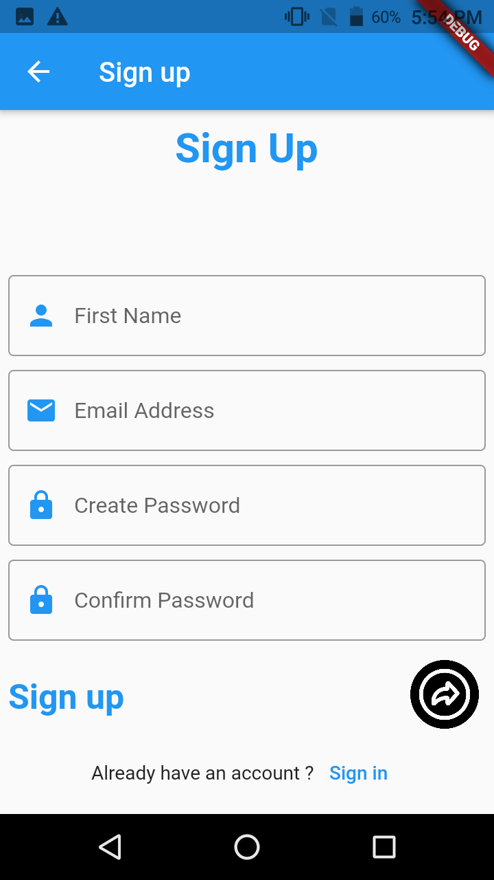

## Home

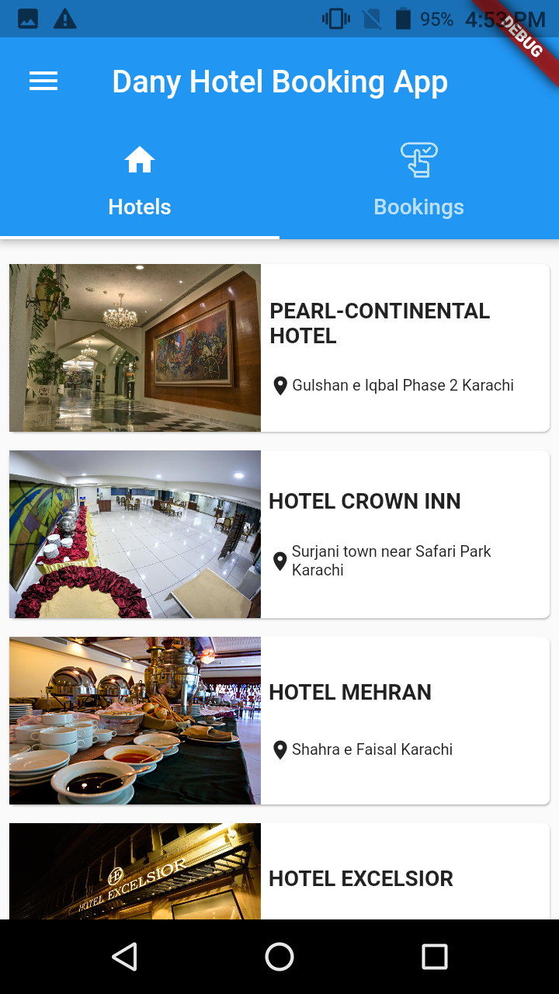

## Booking

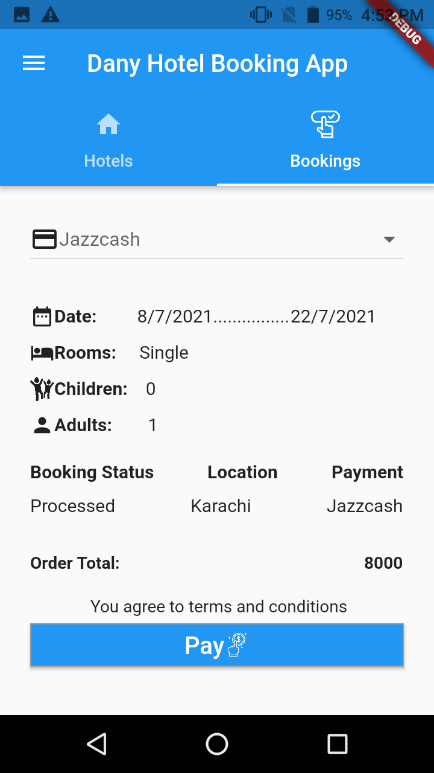

## Drawer

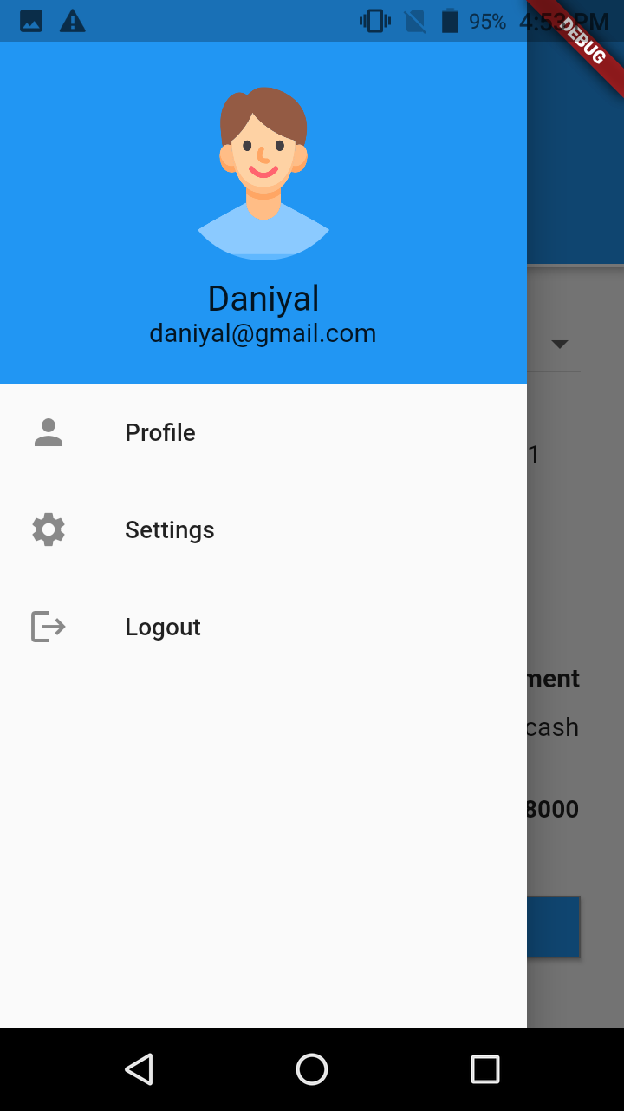

## Hotel Info

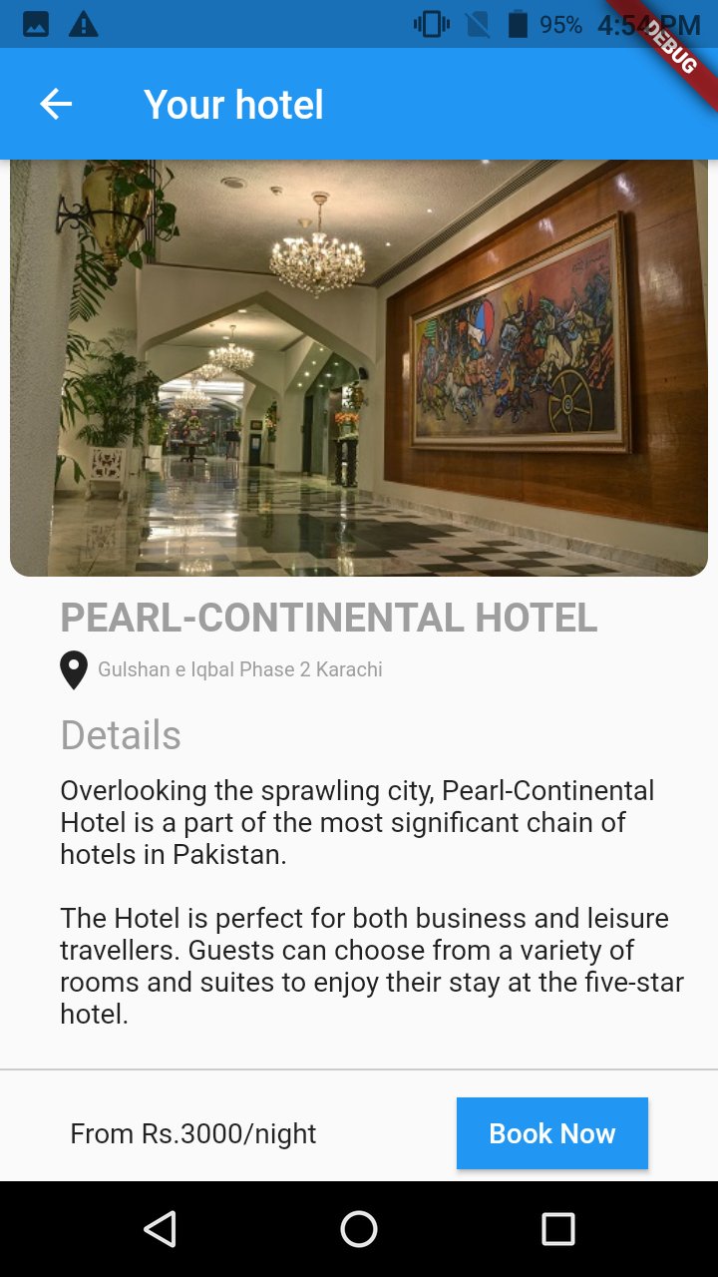

## Reservation

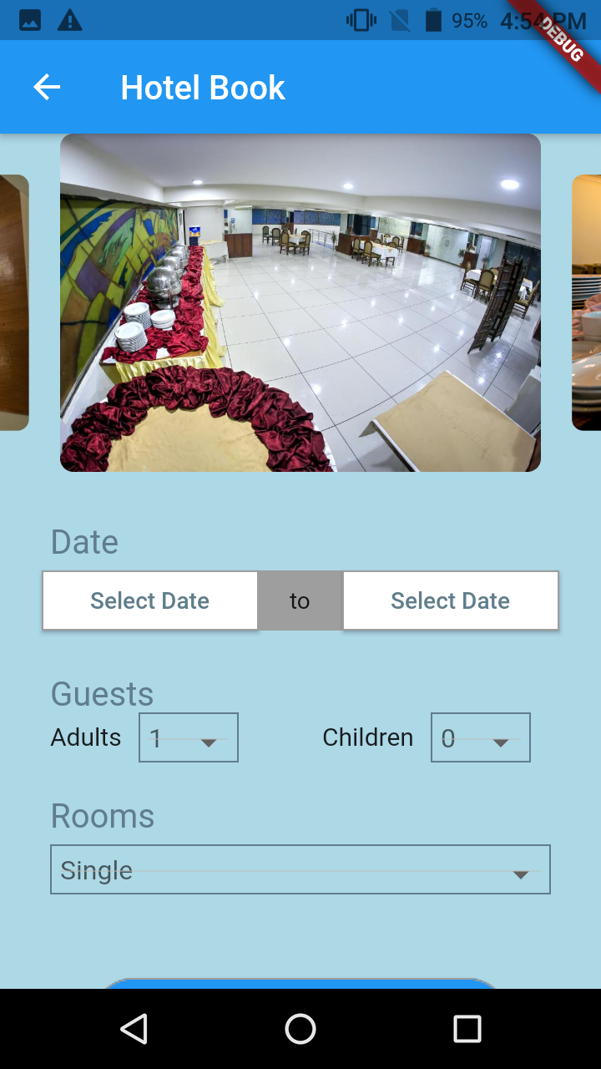

## Date Picker

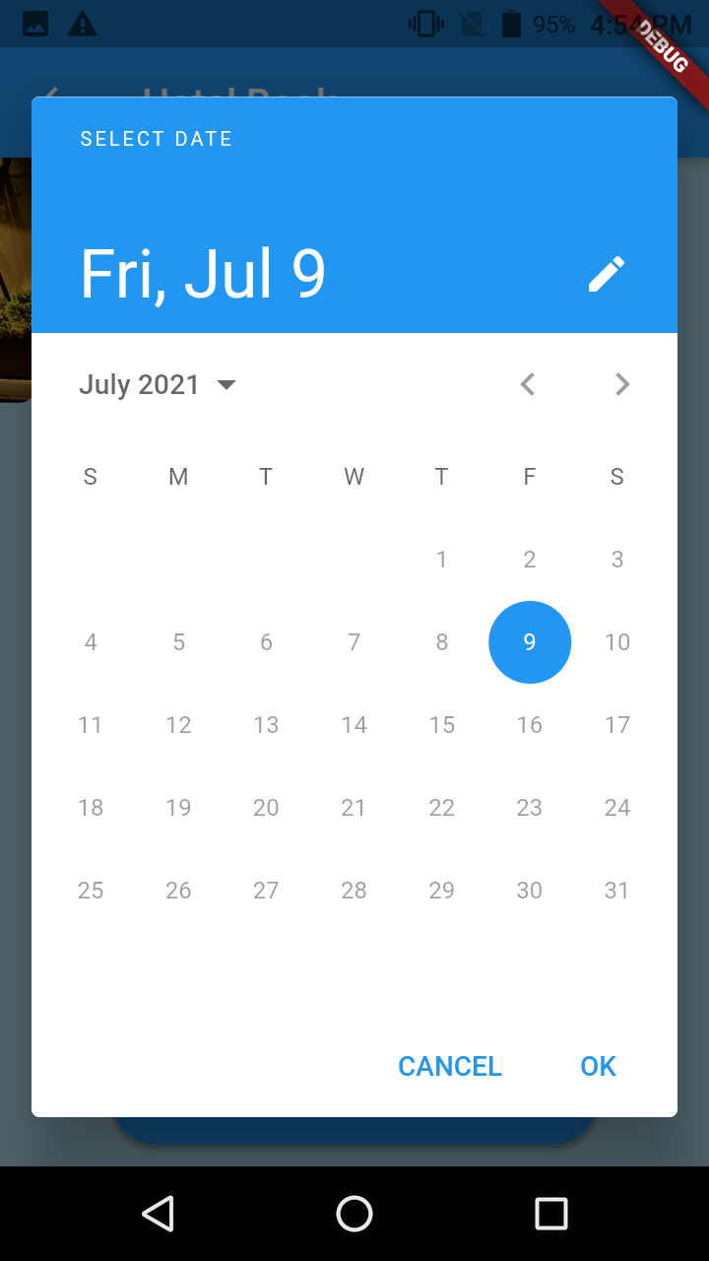

# **Testing**

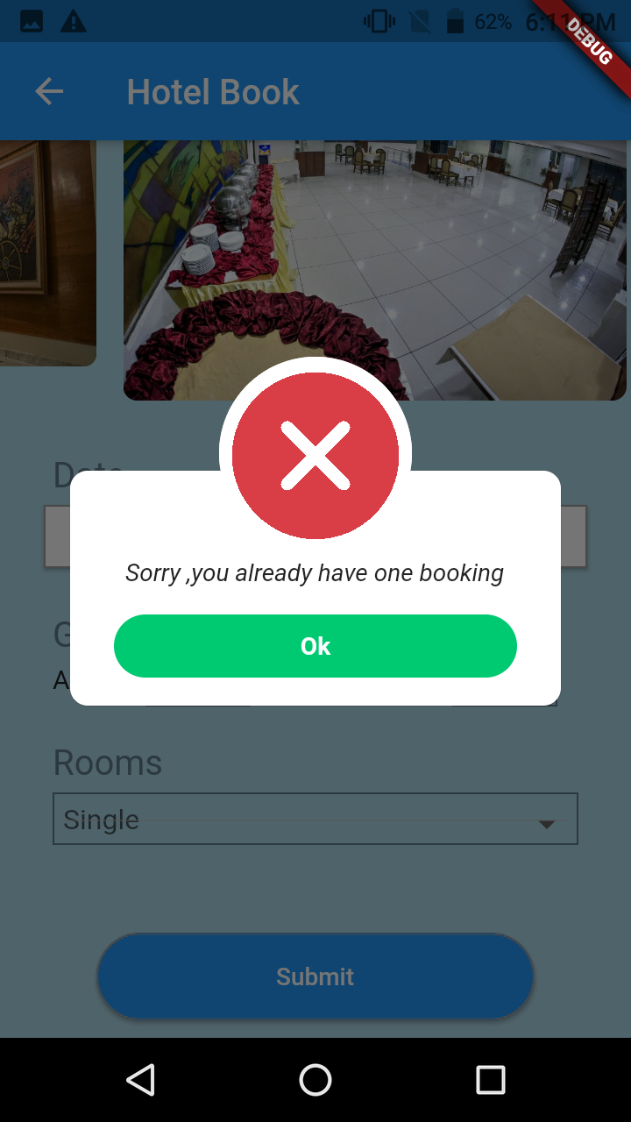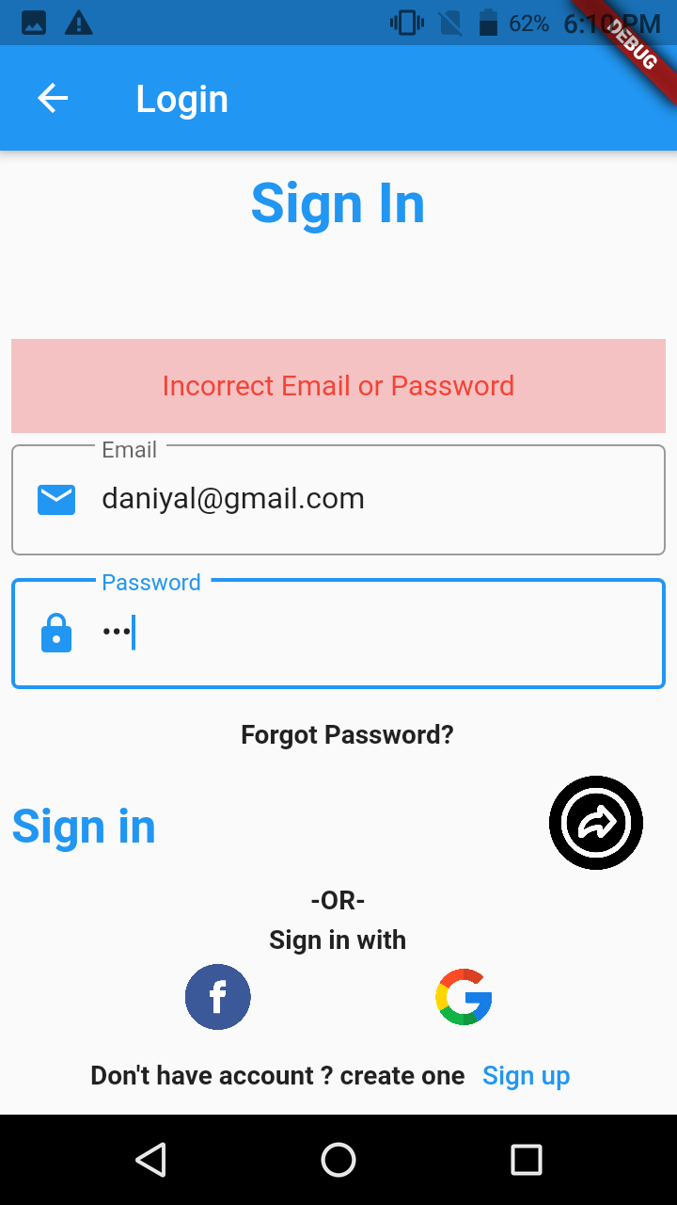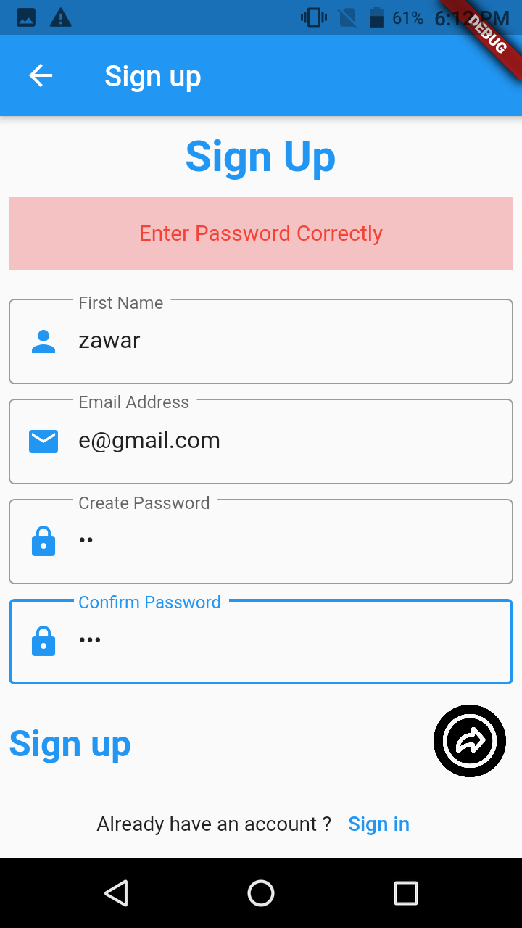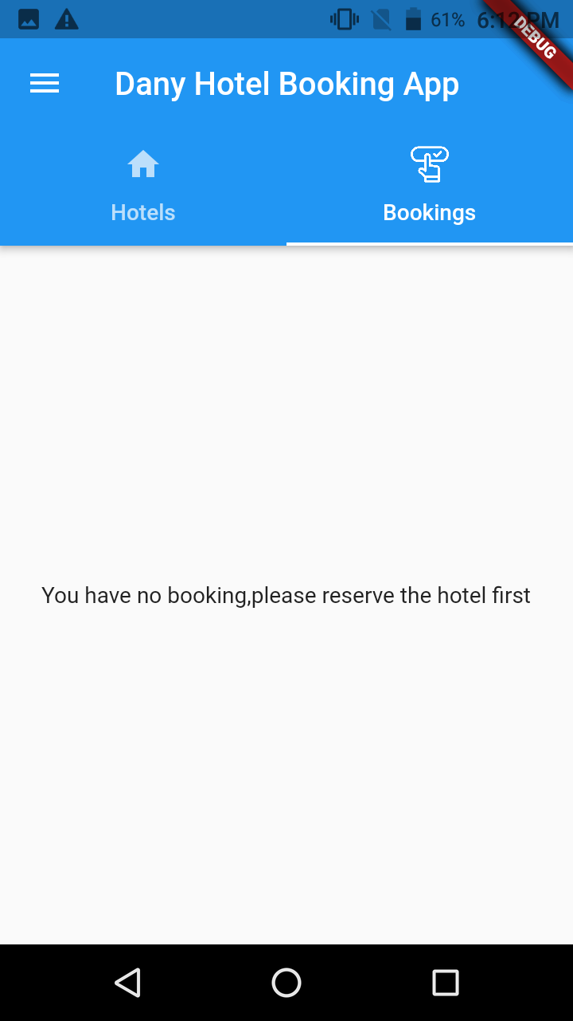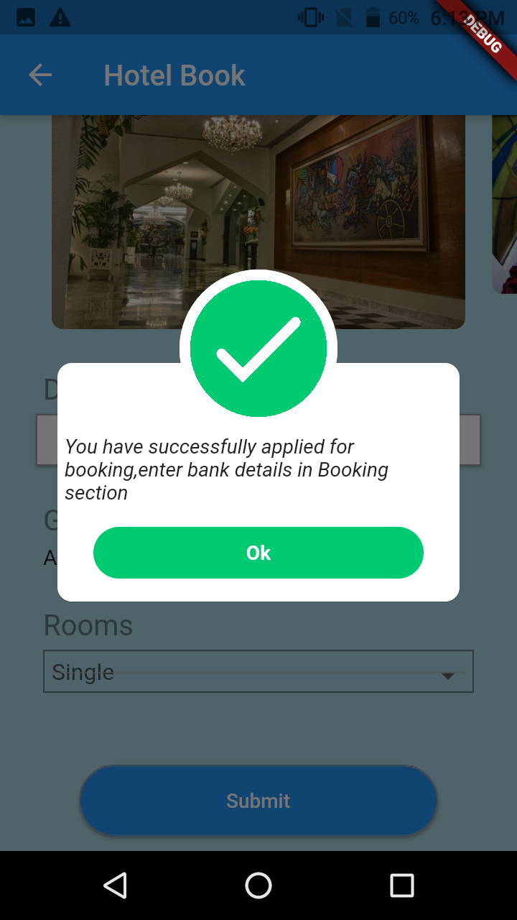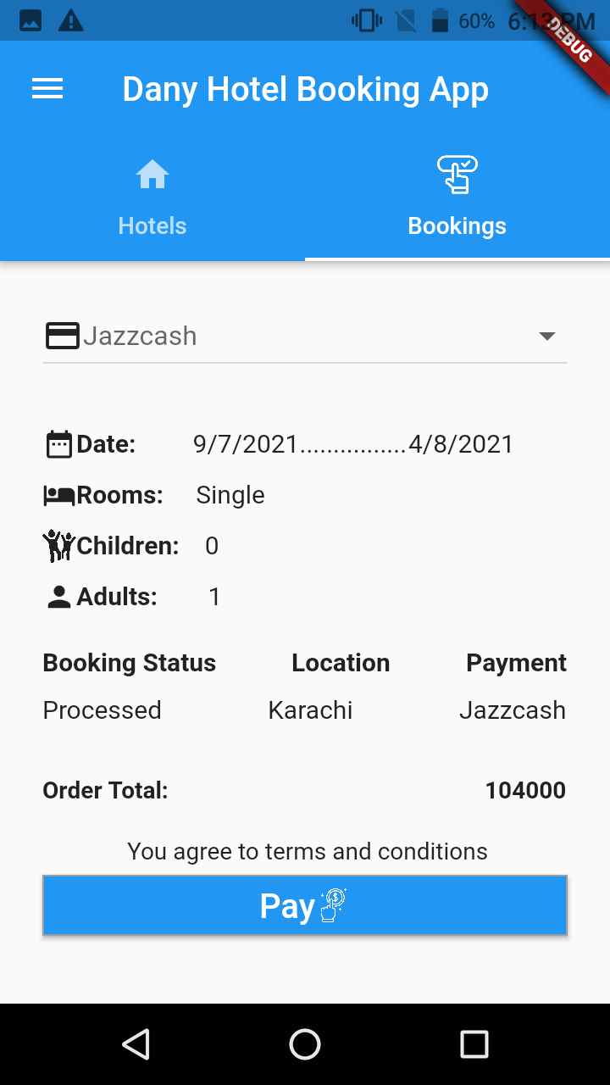

# **App recording and Source Code Link:**

<https://drive.google.com/drive/folders/1S86j54WH_CqOv4Q66fPfWVro09yC_shP?usp=sharing>